GVP Leave Management System Manual

There are three type of users in this system

1 – Admin user (VC/Registrar/Sub registrar/ Admin Department)
2 – HOD (Department Head)
3 – Staff user (Employee)

-> user Create

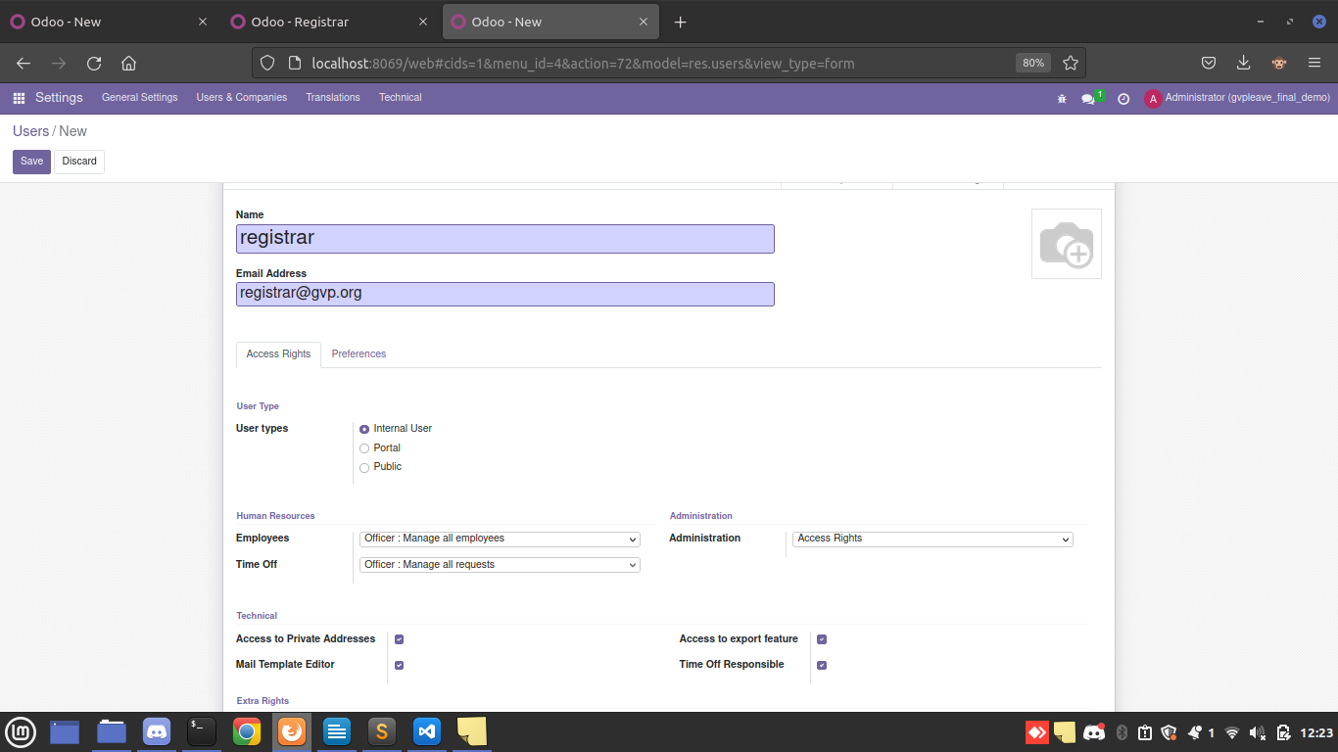
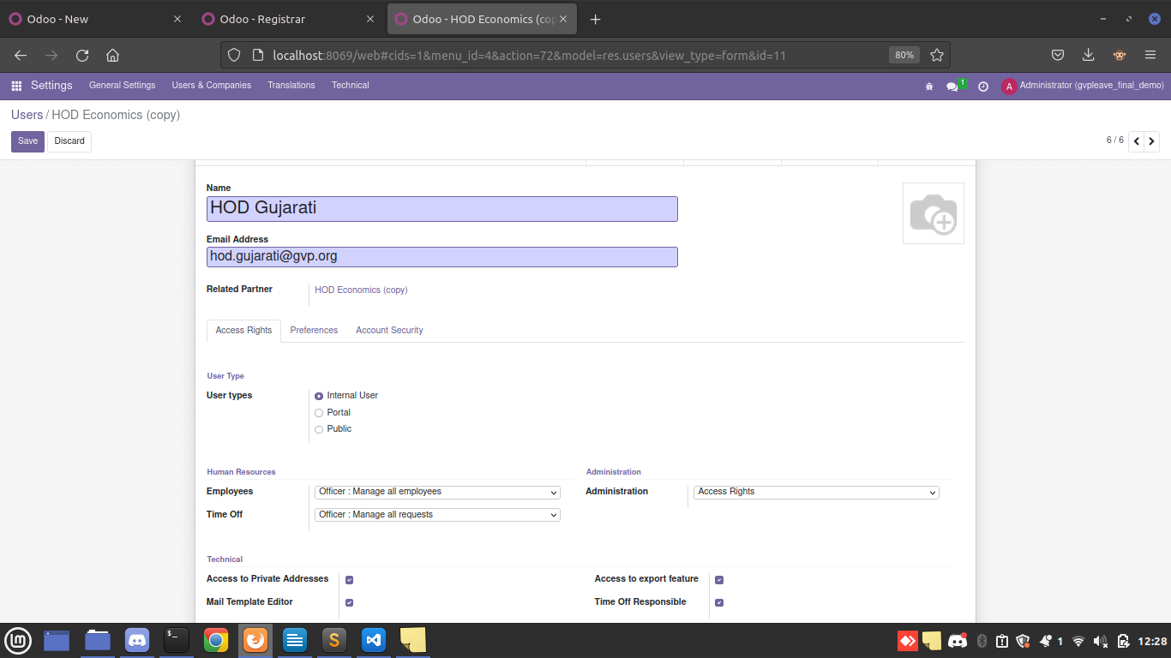
-> user for HOD

-> User normal staff user

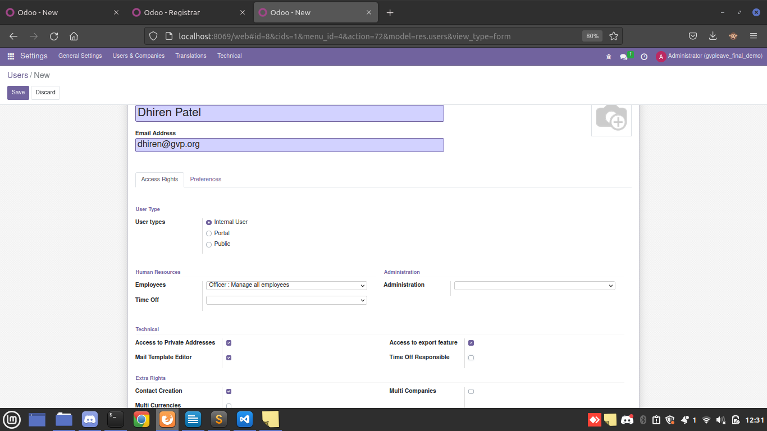

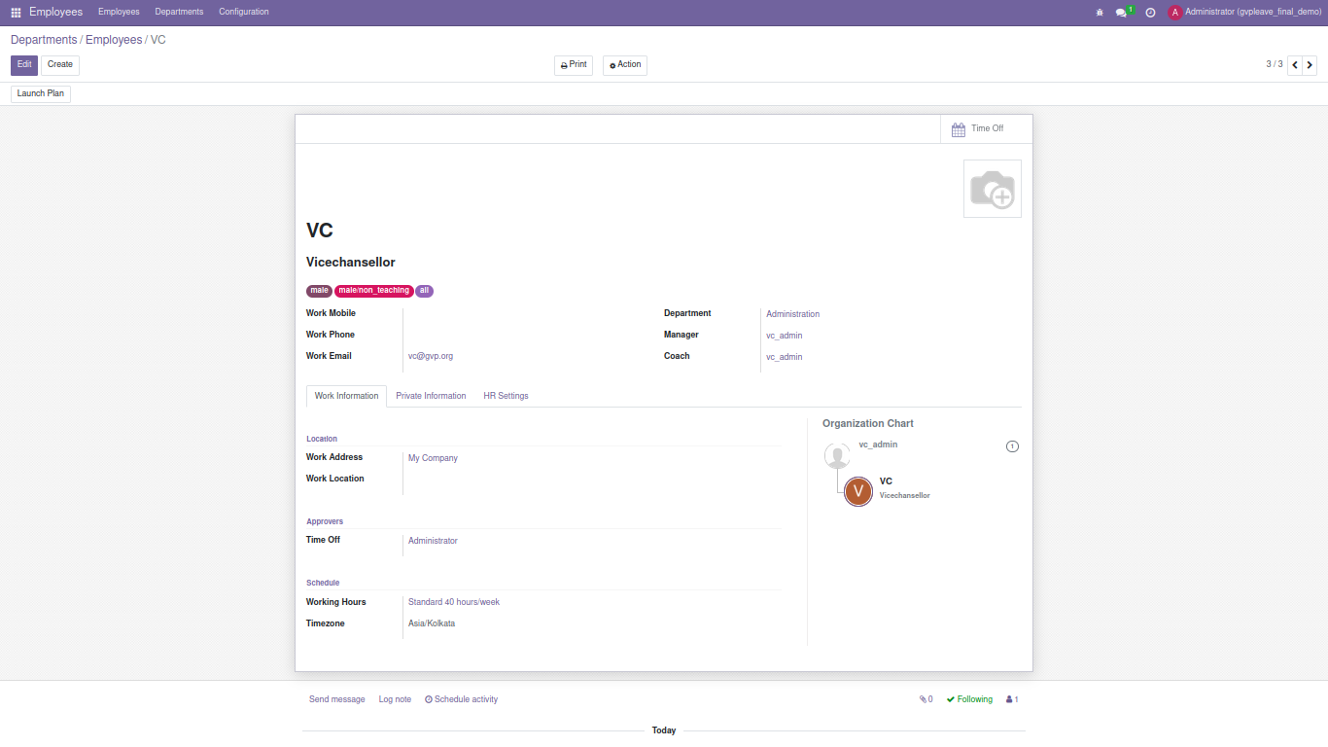
-> Employee Create

-> Private Information

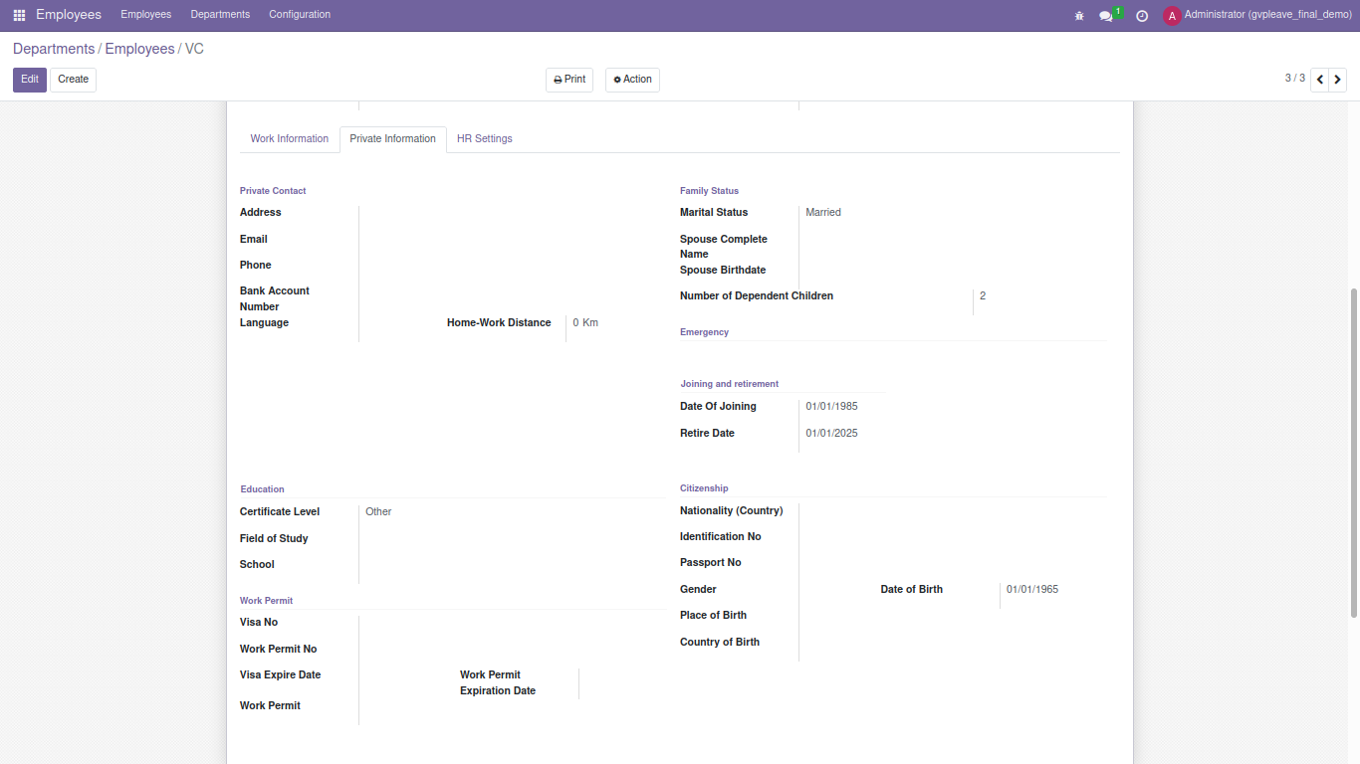

-> HR Setting
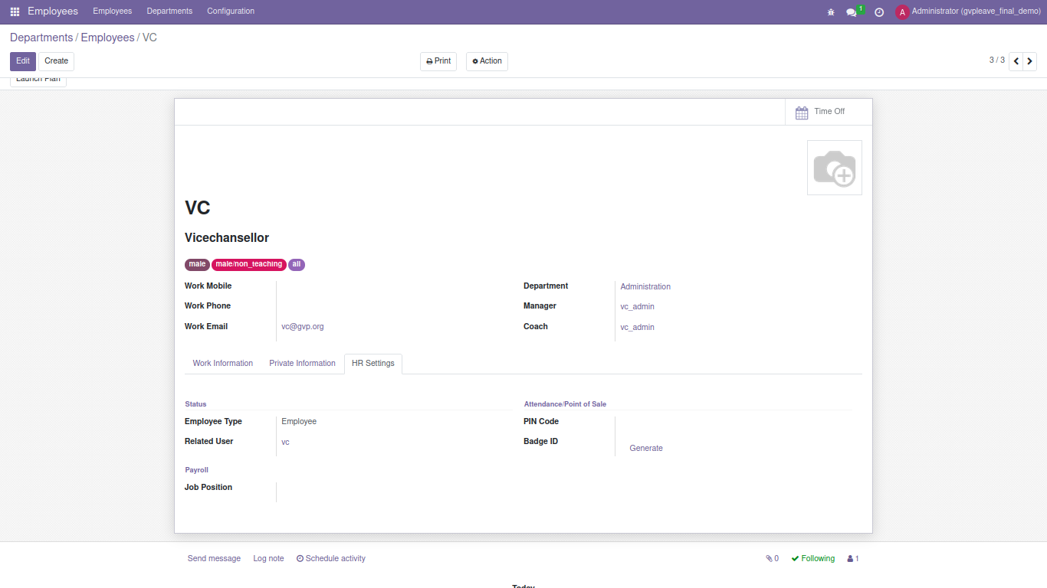

-> User assign for HOD

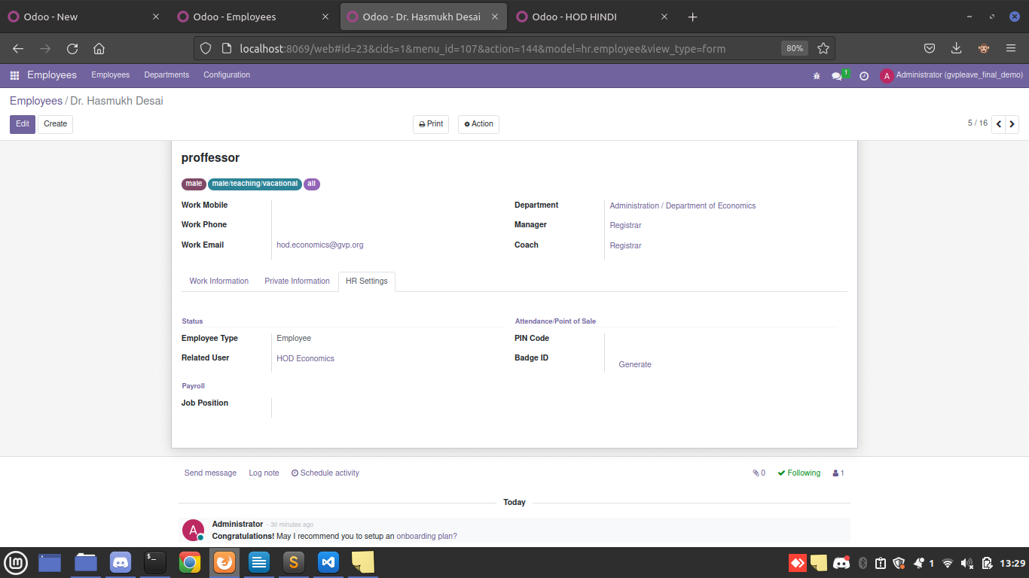

-> Department Create

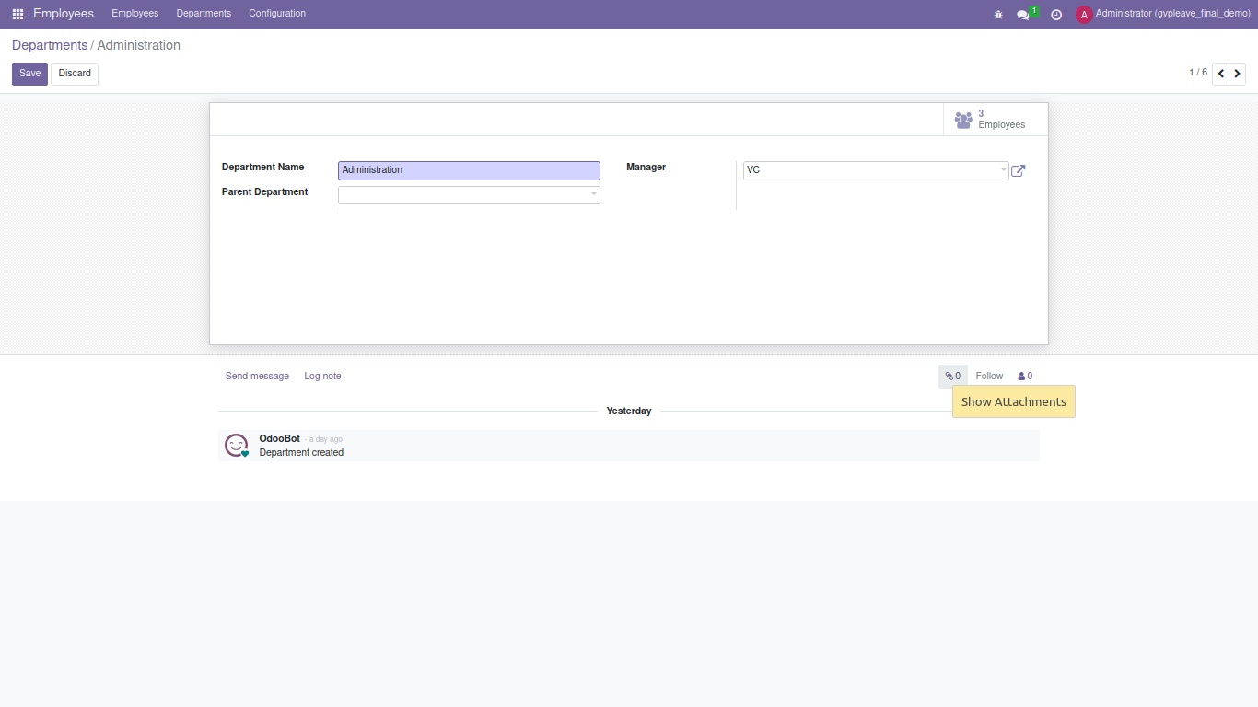

Leave Creation

-> Time Off -> Configuration -> Time off Types

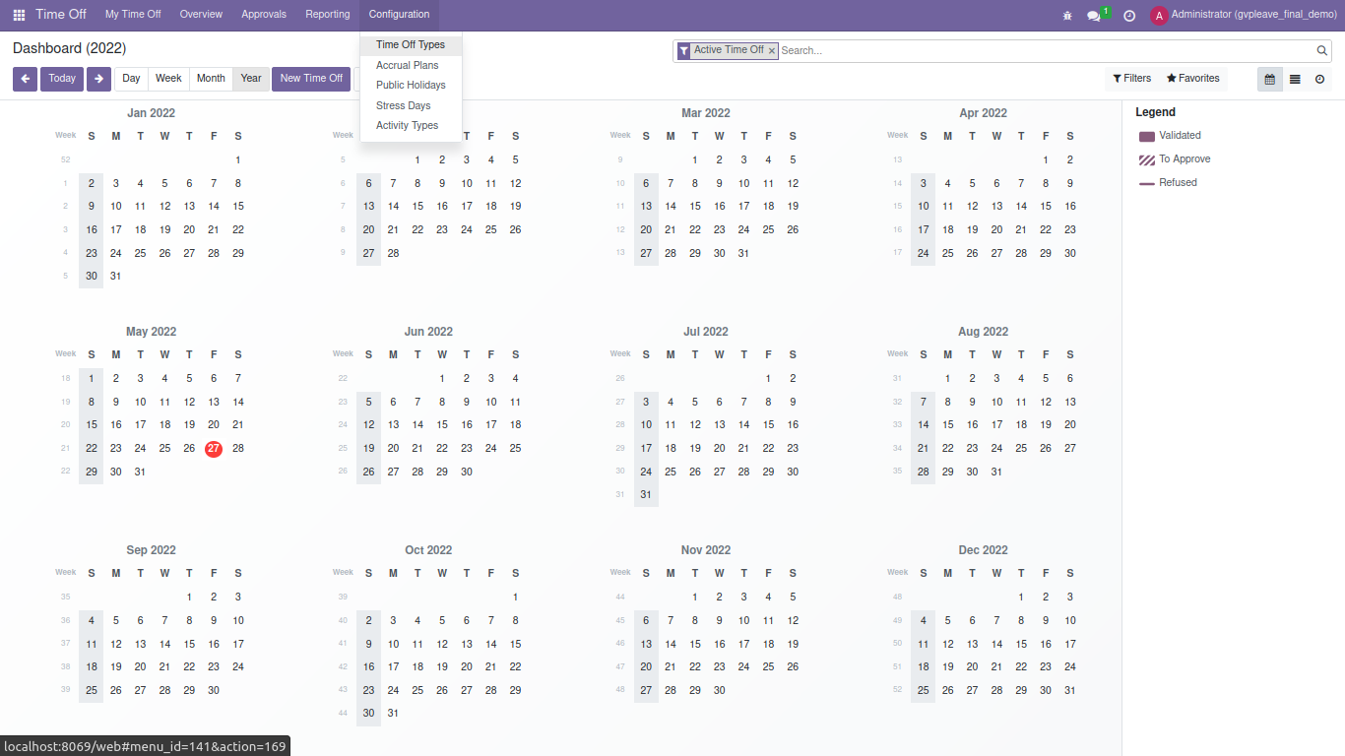

-> Leave Create Form

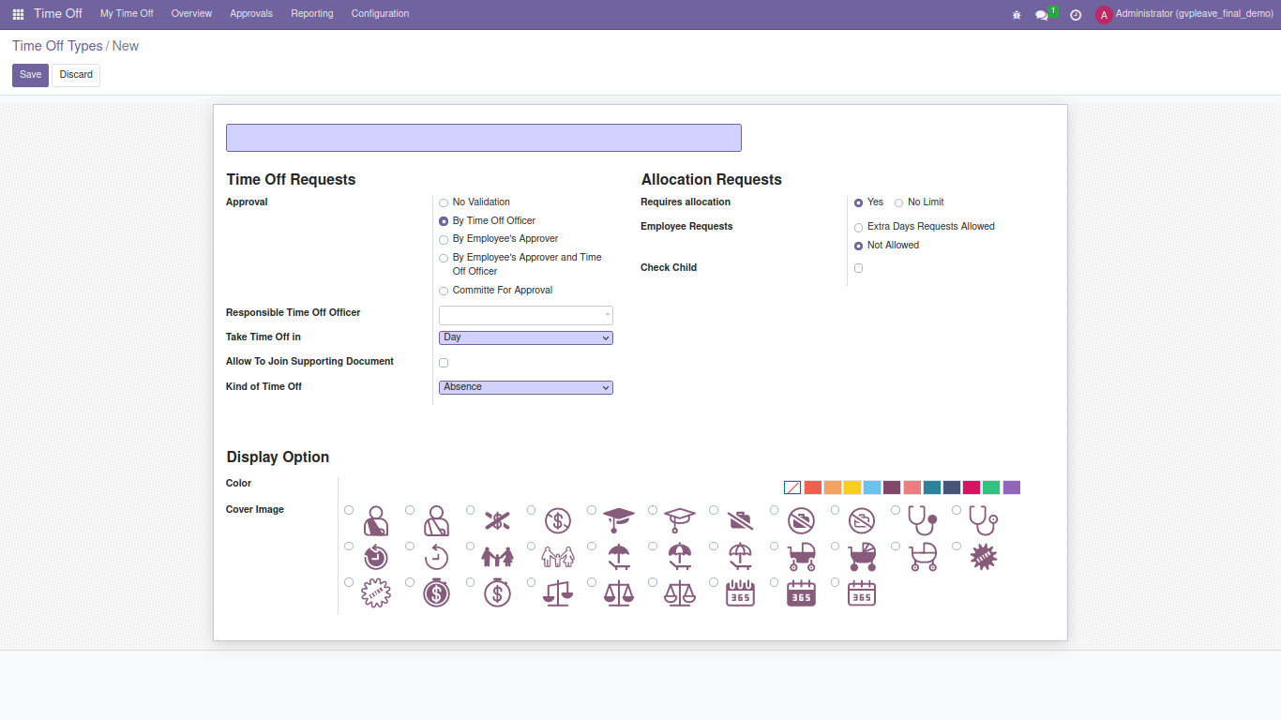

1- Earned Leave

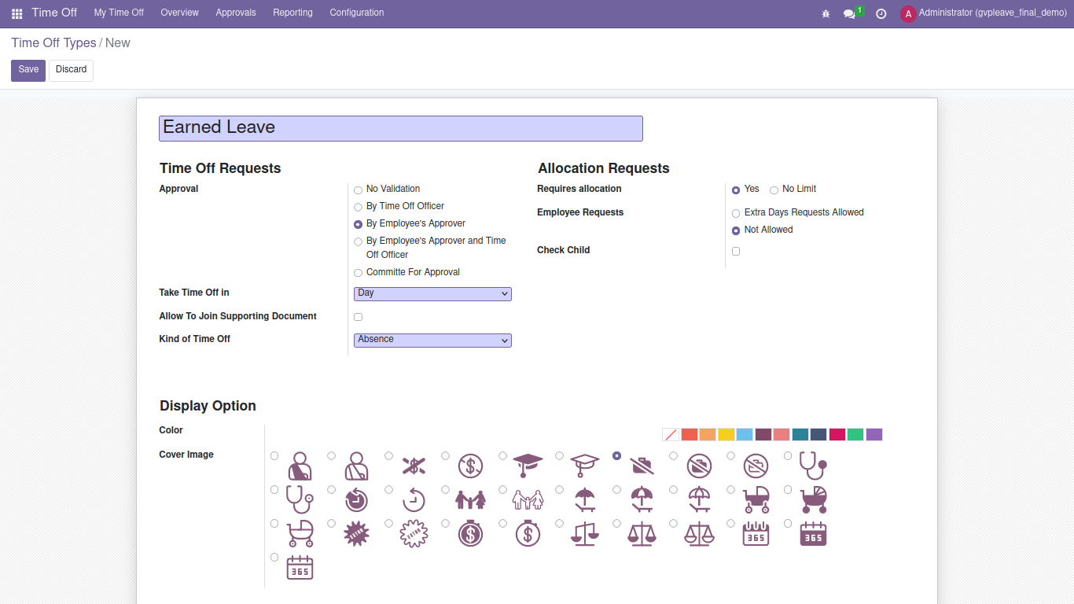
- By Empoyee’s Approver -> Department Head can approve this leave

2 – Seek Leave

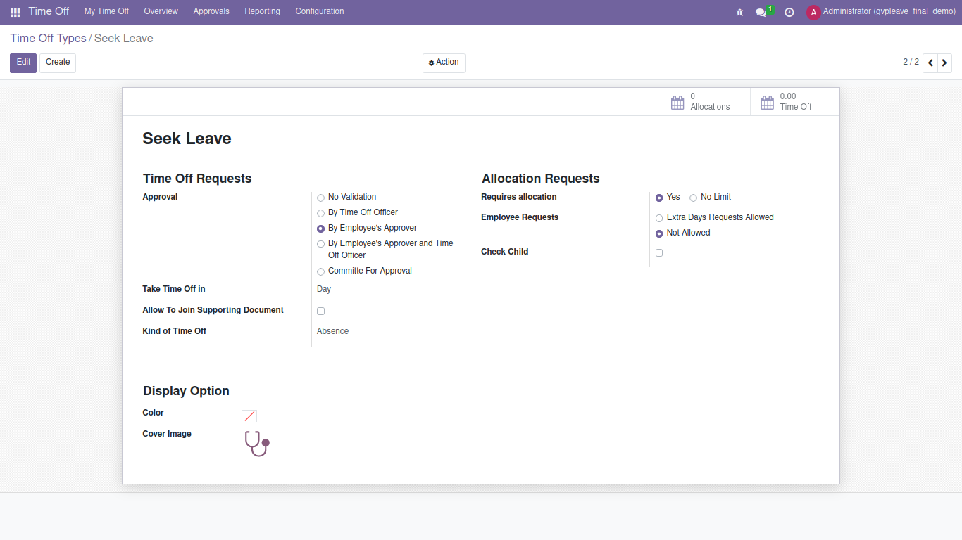

3 – Maternity Leave

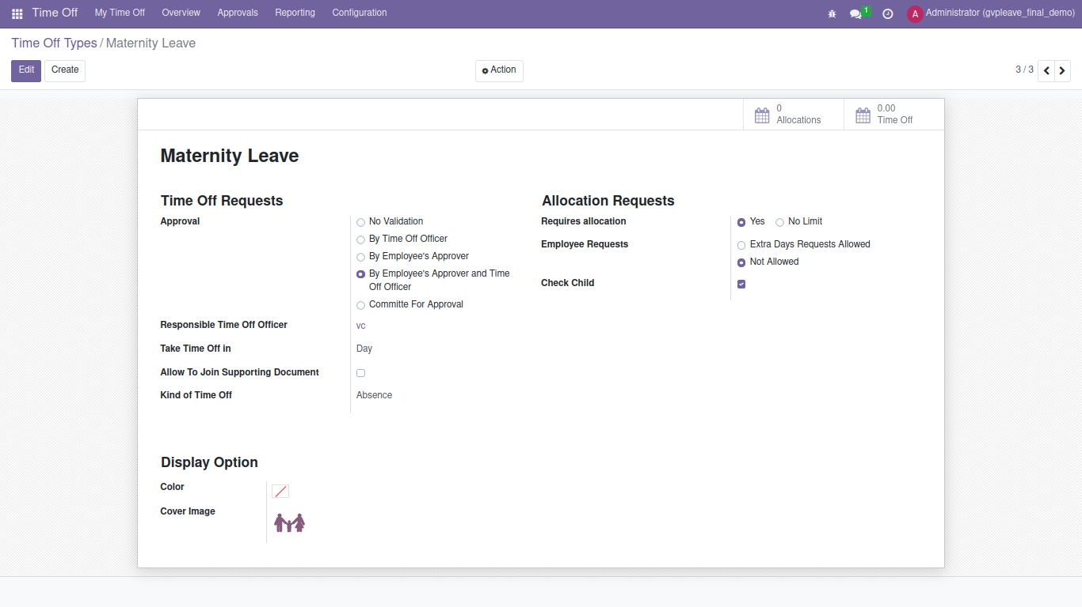
- Maternity leave approve by 2 level
1- HOD
2- Admin Department (VC/Regustrar)

- Check Child -> 2 child not allow to take leave
- less then 1 year of service not allow to take leave

4 – Paternity Leave
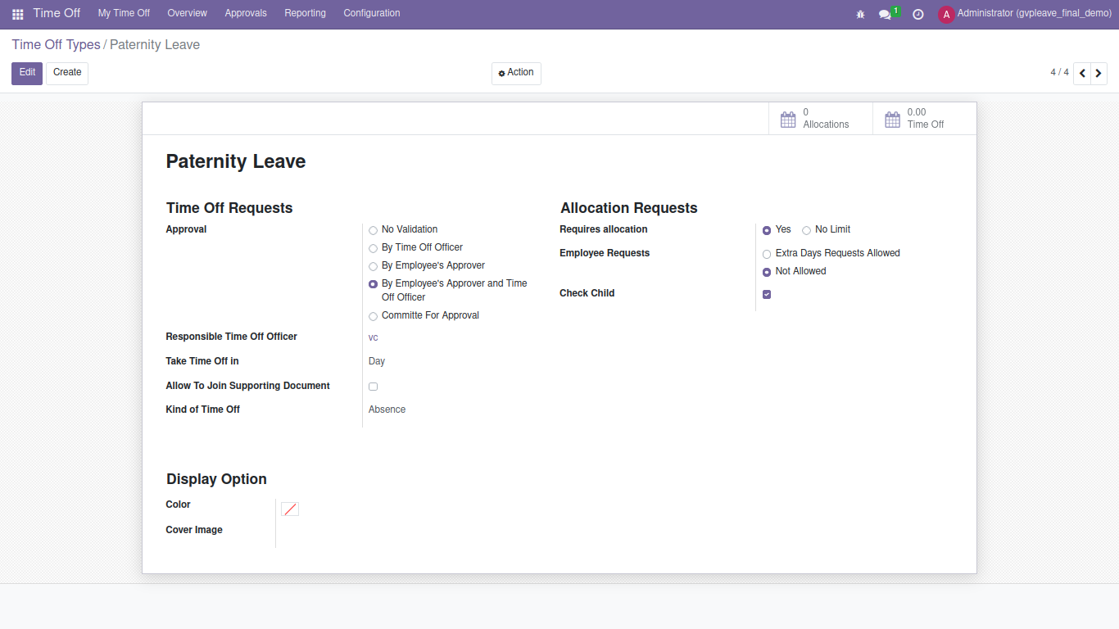

- Paternity leave approve by 2 level
1- HOD
2- Admin Department (VC/Regustrar)

- Check Child -> 2 child not allow to take leave

5 – Subatical Leave

- In this leave approve by committee members
- Committee members add at the time of leave create

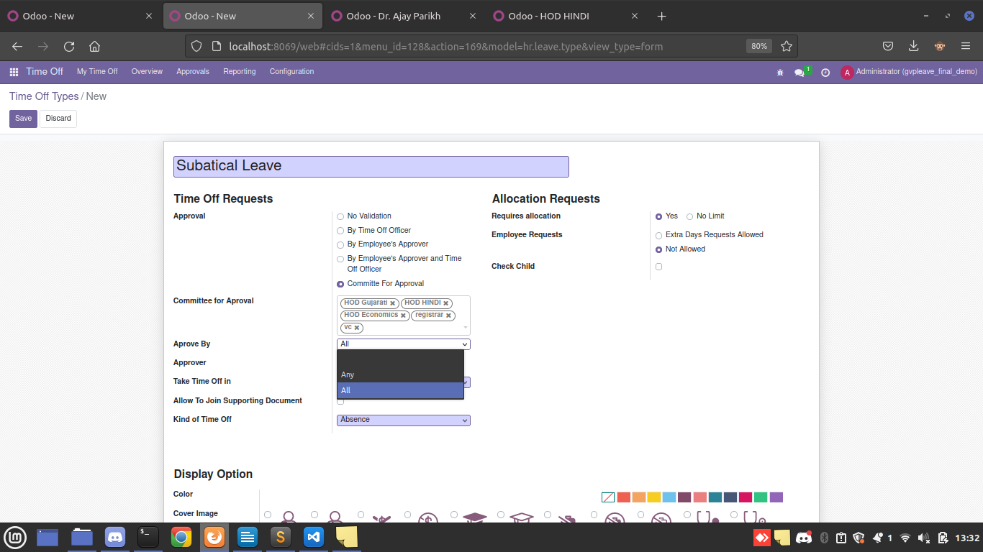
- there are two options for approval
- All – All committee menbers can aprrove leave then after leave approved
- Any – any of all employee can approve leave (which are given count)

Leave Allocation
1 – Leave Allocate all employee

- Approvals -> Allocation

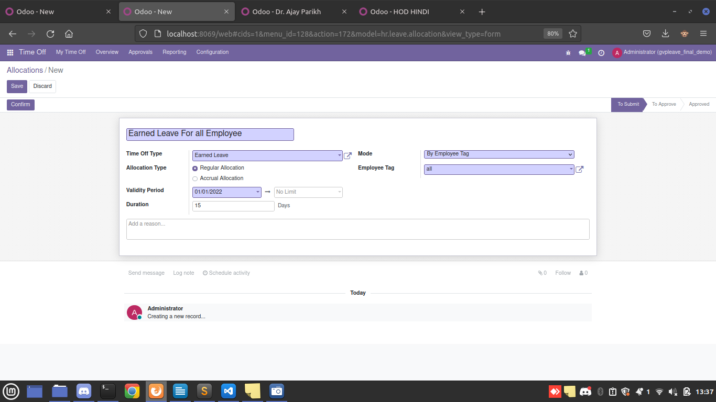

- Assign using employee tag

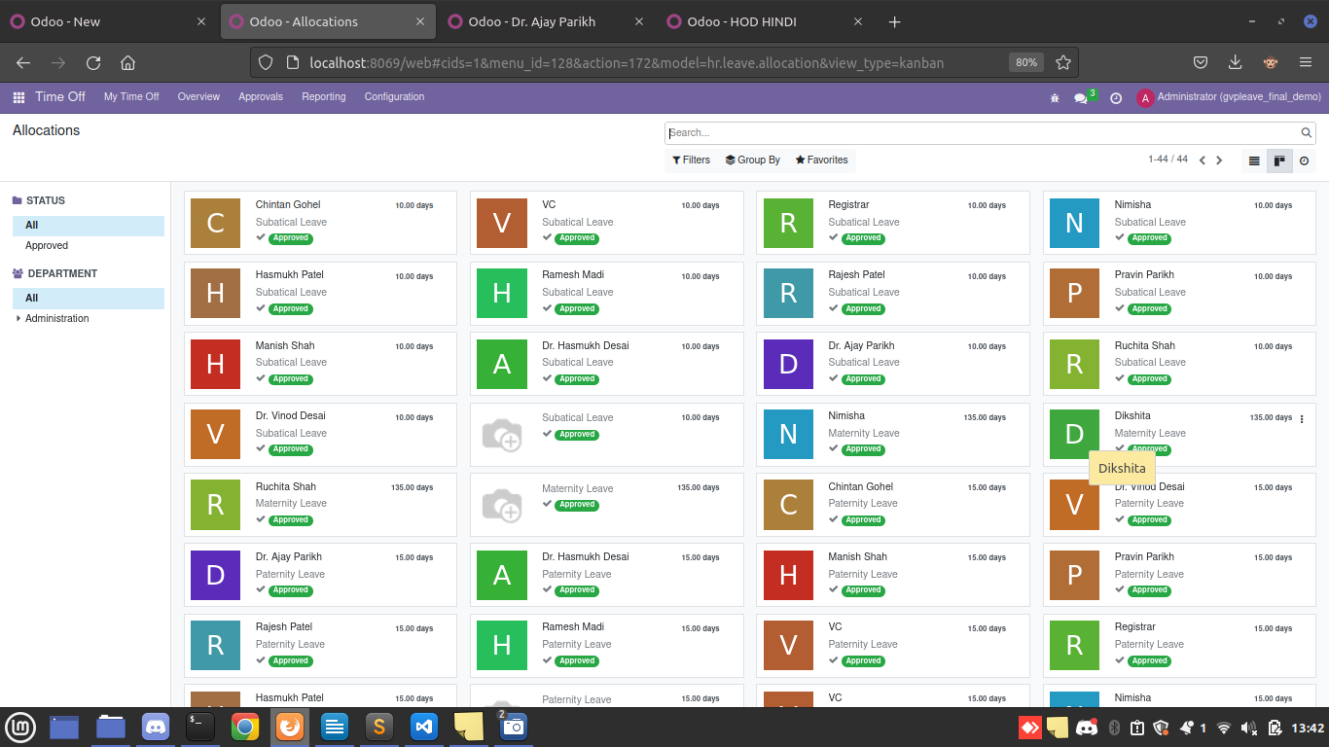
2 – Allocated Leave view for all employee

Normal User View

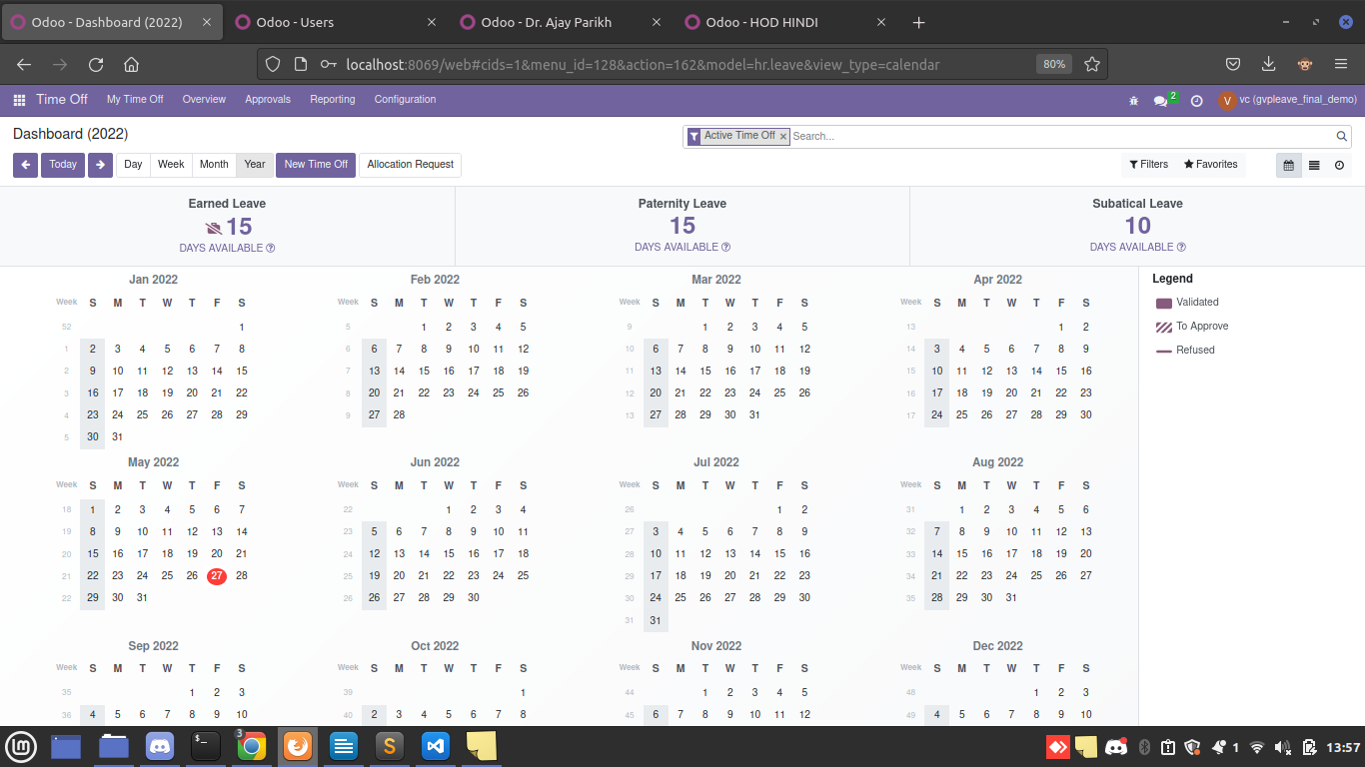
- Login into system -> Time Off overview/ dashboard

1- View Allocated Leaves

-> My Time Off -> My Allocation
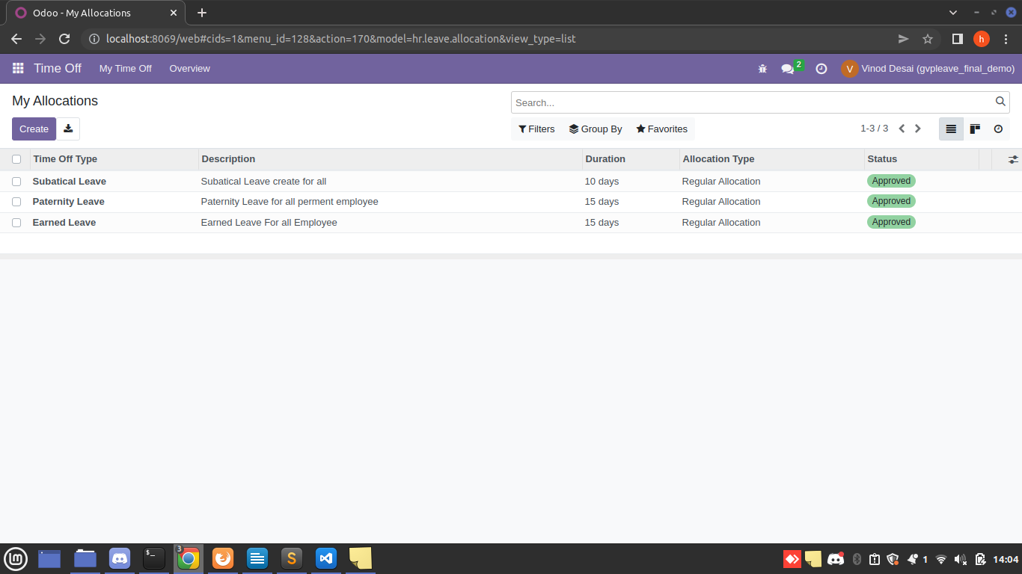

2- Create Leave request
-> by clicking New Time off button or
-> My Time Off -> My Time Off -> click create button

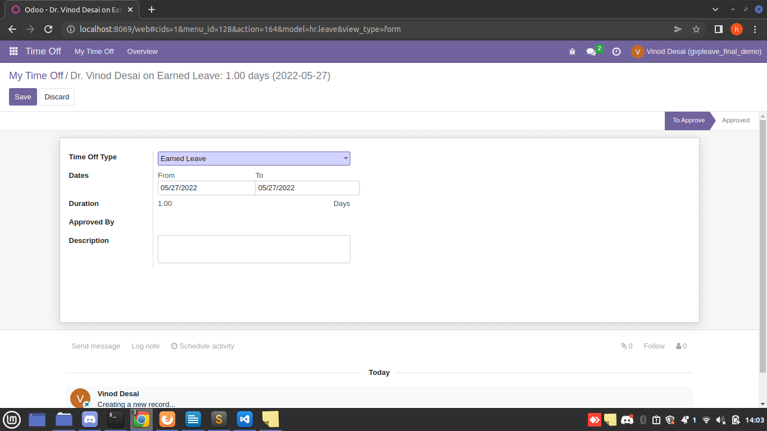

3- Activity for approval (Single Approval)

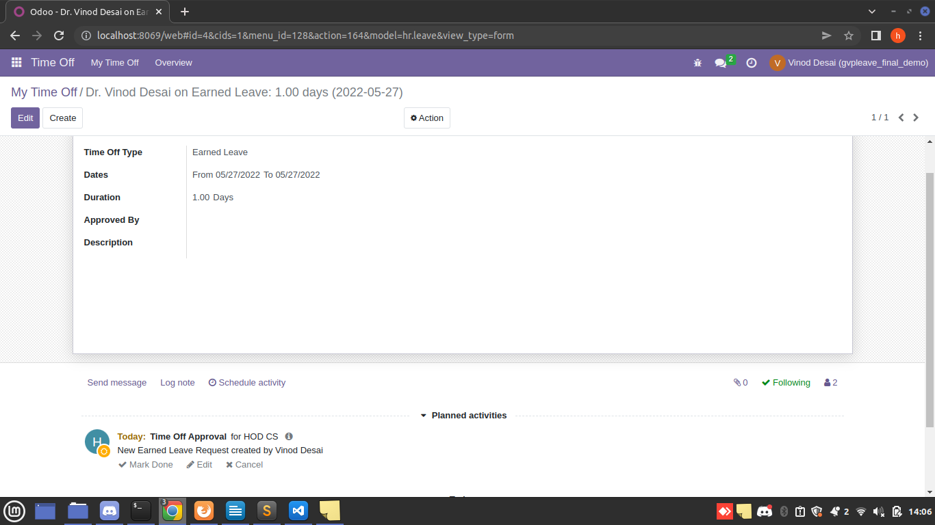

4 – Create Leave request for committe approvals

1- Leave request

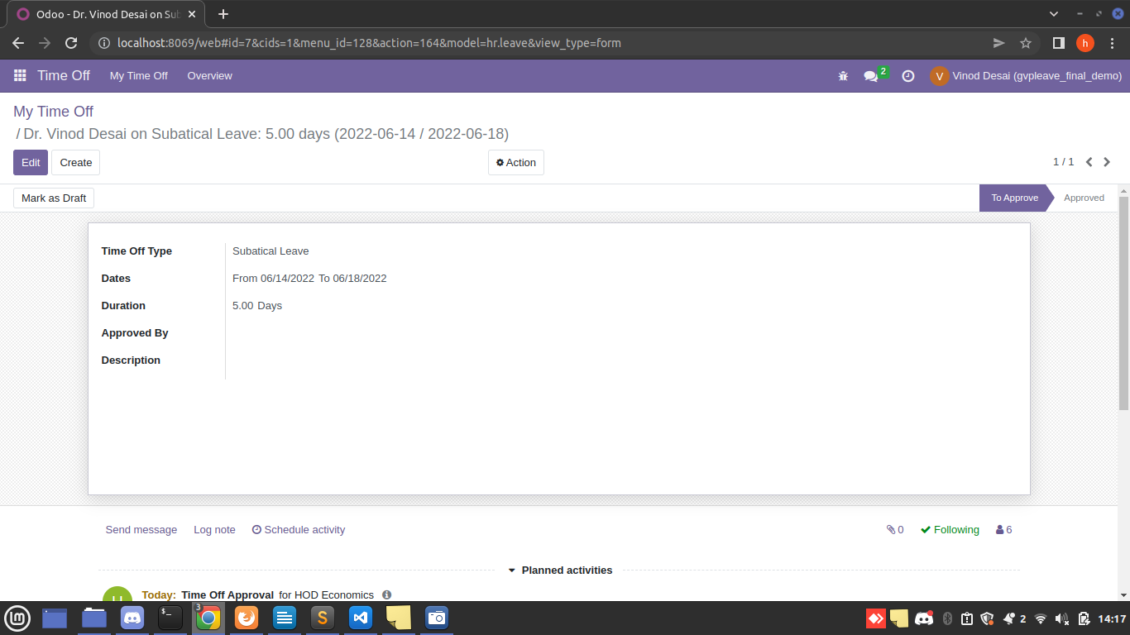

2 – Schedule Activity which all committe menbers are added

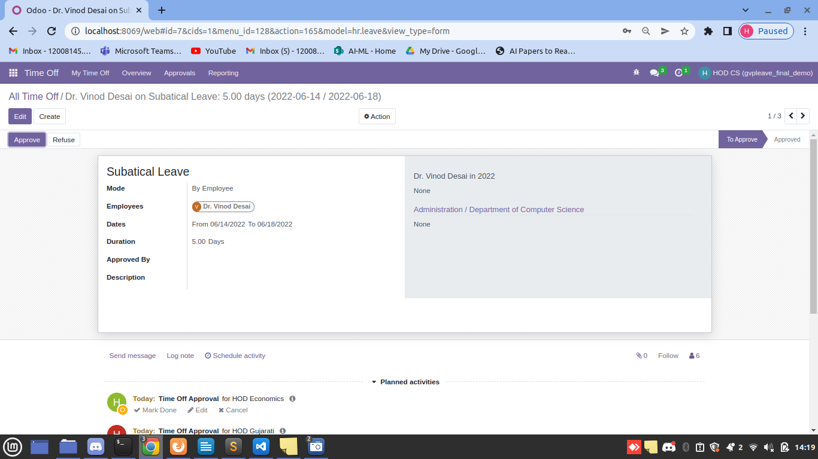

3 – one by one who is approve this leave they added in Approve By list and Done Activity for this user

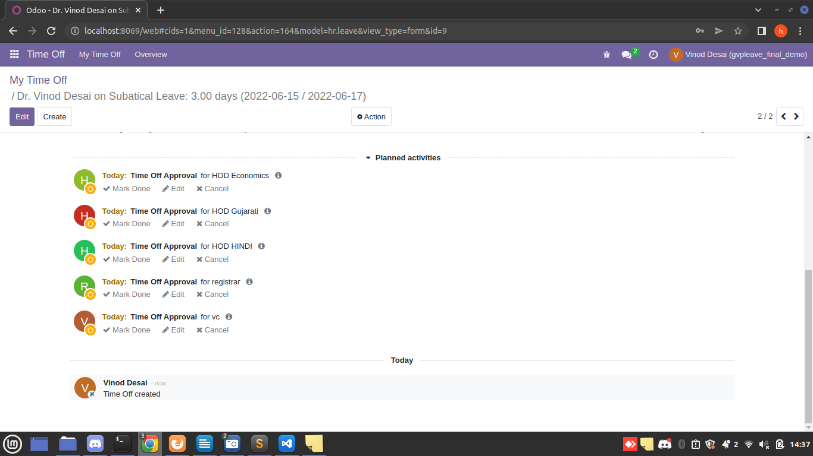

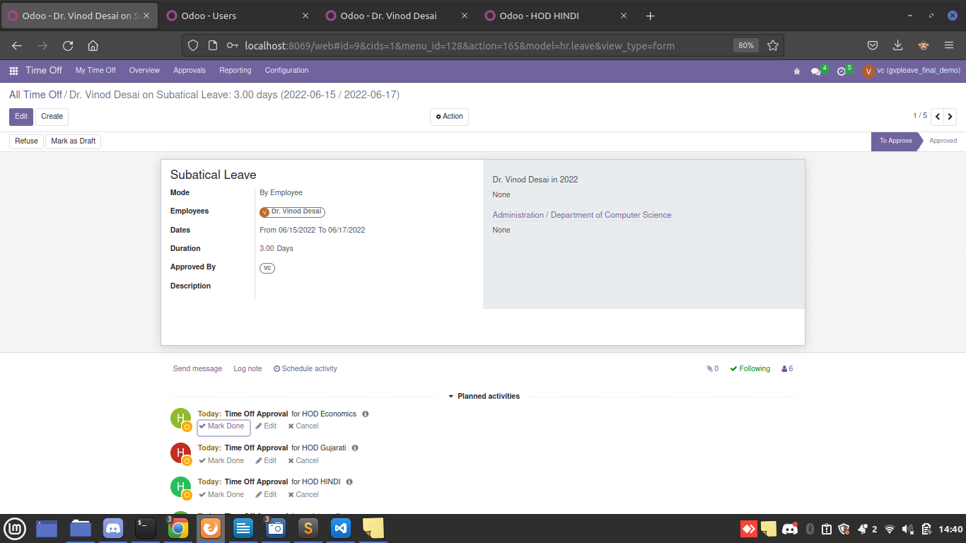

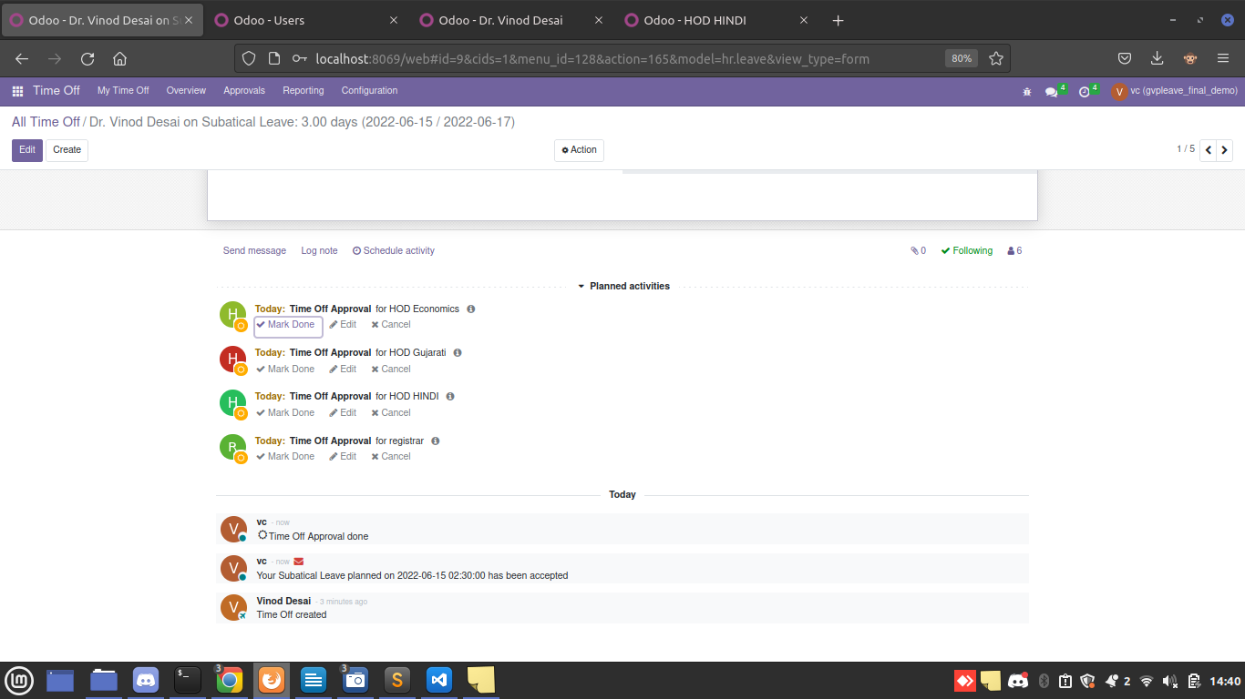

Leave for 2 level Approval
HOD view

1- 2 level approval leave

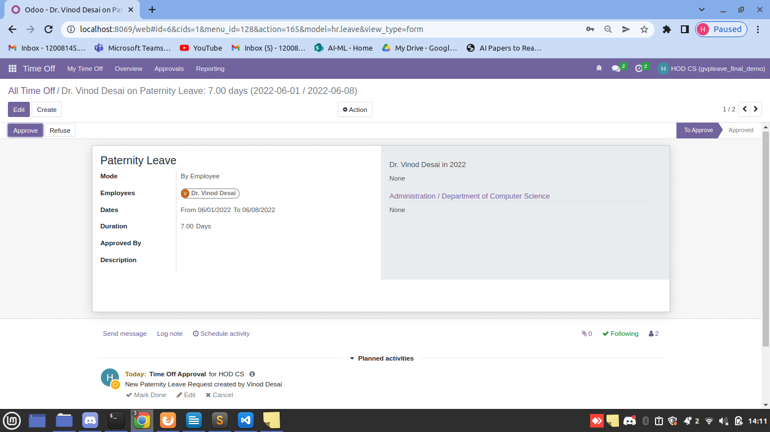
-> approve by HOD and schedule automatic activity to second approval and state change to second approval

